**Task :- Html File** Date:-30 july 2024

<!DOCTYPE html>

<html lang="en">

<head>

    <meta charset="UTF-8">

    <meta name="viewport" content="width=device-width, initial-scale=1.0">

    <title>Document</title>

    <link rel="stylesheet" href="style.css">

</head>

<body>

    <div class="container">

        <div class="box">Hello</div>

        <div id="back"></div>

    </div>

</body>

</html>

**Css File :-**

*{

    margin: 0;

    padding: 0;

    box-sizing: border-box;

}

html,body{

    height: 100%;

    width: 100%;

}

body{

    display: flex;

    justify-content: center;

    align-items: center;

}

.container{

    background-color: aquamarine;

    height: 80vh;

    width: 80vw;

    display: flex;

    justify-content: center;

    align-items: center;

}

#back{

    background-color: black;

    height: 100px;

    width: 100px;

}

.box{

    position: absolute;

    background-color: rgb(255, 0, 0, 0.58);

    color: aliceblue;

    font-size: 40px;

    height: 100px;

    width: 100px;

    border: 2px solid black;

    /* 2D */

    /* transform: scale(1); */

    /* transform: rotate(1turn); */

    /* transform: rotate(360deg); */

    /* transform: skew(20deg); */

    /* transform: skew(20deg, 20deg) */

    /* transform: skewX-20deg); */

    /* transform: skewY(-20deg); */

    /* transform: translateX(-40px); */

    /* transform: translateY(-60px); */

    /* transform: translateY(30px,); */

    /* transform: translateY(20px); */

    /* transform: translateY(50%); */

    /* transform: translateY(100% , 100%); */

    /* 3D */

    /* transform: rotateX(40deg) perspective(500px); */

    /* transform: rotateY(40deg) perspective(500px); */

     transform: perspective(500px) rotateX(50deg);

}

**O/p:-**

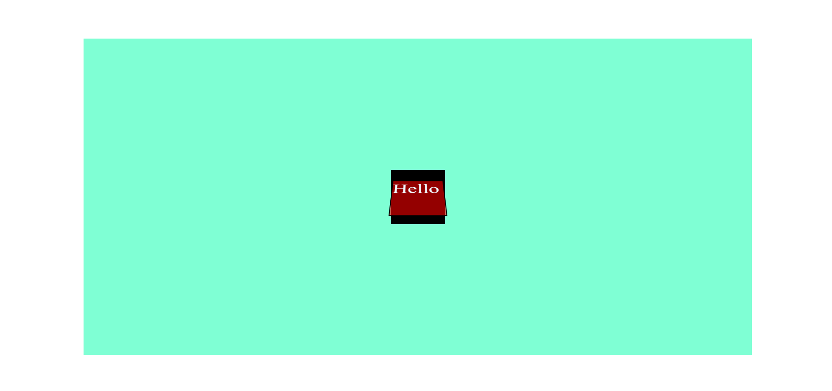

**Task :- Html File** Date:- 31 july 2024

<!DOCTYPE html>

<html lang="en">

<head>

    <meta charset="UTF-8">

    <meta name="viewport" content="width=device-width, initial-scale=1.0">

    <title>Document</title>

    <link rel="stylesheet" href="style.css">

</head>

<body>

    <div class="container">

        <div class="box">

            <div class="cover" id="c1">👆</div>

        </div>

        <div class="box">

            <div class="cover" id="c2">👆</div>

        </div>

        <div class="box">

            <div class="cover" id="c3">👆</div>

        </div>

        <div class="box">

            <div class="cover" id="c4">👆</div>

        </div>

        <div class="box">

            <div class="cover" id="c5">👆</div>

        </div>

        <div class="box">

            <div class="cover" id="c6">👆</div>

        </div>

        <div class="box">

            <div class="cover" id="c7">👆</div>

        </div>

        <div class="box">

            <div class="cover" id="c8">👆</div>

        </div>

        <div class="box">

            <div class="cover" id="c9">👆</div>

        </div>

    </div>

</body>

</html>

**CSS File :-**

*{

    margin: 0;

    padding: 0;

    box-sizing: border-box;

}

html,body{

    width: 100%;

    height: 100%;

}

.box{

    height: 100px;

    width: 150px;

    background-color: aquamarine;

}

.cover{

    background-color: #23c1ff78;

    height: 100%;

    width: 100%;

    border: 1px solid black;

    display: flex;

    justify-content: center;

    align-items: center;

    font-size: 35px;

}

.container{

    height: 100vh;

    display: grid;

    grid-template-columns: repeat(3, 1fr);

    grid-template-rows: repeat(3, 200px);

    justify-items: center;

    align-items: center;

    justify-content: center;

    align-content: center;

}

#c1:hover{

    transform: rotate(3600deg);

    transition-property: all;

    transition-duration: 2s;

    transition-timing-function: linear;

    /* transition-delay: 2s; */

}

#c2:hover{

    /* transform: translate(0px, 40px); */

    /* transform: translateX(20px); */

    transform: translateY(2cm) ;

    transition-property: all;

    transition-duration: 1s;

    transition-timing-function: linear;

    /* transition-delay: 2s; */

}

#c3:hover{

    /* transform: skew(0deg, 20deg); */

    /* transform: skewX(20deg); */

    transform: skewY(20deg);

    transition-property: all;

    transition-duration: 1s;

    transition-timing-function: linear;

    /* transition-delay: 2s; */

}

#c4:hover{

    transform: scale(1.5);

    transition-property: all;

    transition-duration: 1s;

    transition-timing-function: linear;

    /* transition-delay: 2s; */

}

#c5:hover{

    transform: perspective(400px) rotateX(60deg);

    transition-property: all;

    transition-duration: 1s;

    transition-timing-function: linear;

    /* transition-delay: 2s; */

}

#c6:hover{

    transform: perspective(400px) rotateY(3600deg);

    transition-property: all;

    transition-duration: 5s;

    transition-timing-function: linear;

    /* transition-delay: 2s; */

}

#c7:hover{

    background-color: red;

    transition-property: all;

    transition-duration: 1s;

    transition-timing-function: linear;

    /* transition-delay: 2s; */

}

#c8:hover{

    height: 150px;

    /* width: 200px; */

    transition-property: all;

    transition-duration: 1s;

    transition-timing-function: linear;

    /* transition-delay: 2s; */

}

#c9:hover{

    transform: perspective(200px) translate3D(40px, 40px, 40px);

    transition-property: all;

    transition-duration: 1s;

    transition-timing-function: linear;

    /* transition-delay: 2s; */

}

**O/p:-**

